SAFE
Self-Advocacy for Empowerment
SKILLS FOR A STRONGER VOICE!

Develop your confidence to express your views. Bring about positive changes in your life. Know your rights and where to get help and support. Choose as many courses as are helpful to you. All sessions are designed to make a positive difference. Most transport costs are refunded, refreshments and drinks provided and are totally free. The SAFE programme is available to service users, carers and anyone with mental health concerns.
Some courses are also open to staff and volunteers.
CONFIDENTIAL, INDEPENDENT AND FREE
ONE POSITIVE THOUGHT IN THE MORNING CAN CHANGE YOUR
WHOLE DAY!

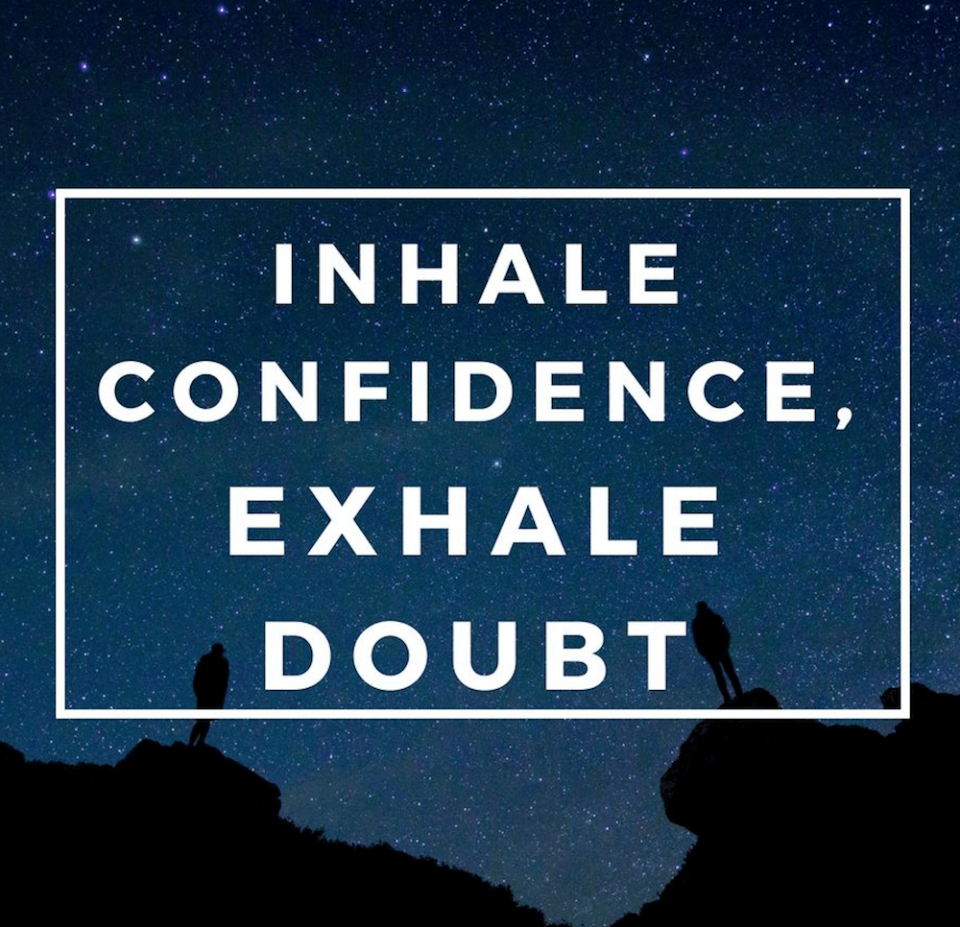
Building Blocks for Confidence
Part 2
A very gentle confidence building course with lots of support and a `no pressure’ approach that will help you find ways to build your confidence…. Particularly if you are new to group situations.
Friday 17th January 2020
12-2:30 Llanrwst

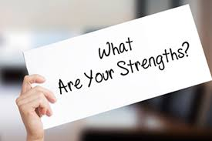
Recognising your Strengths
When we lack confidence, we often forget what we are good at and allow our weaknesses to take control. By recognising our strengths, we can greatly reduce the effect that focusing on our weaknesses would otherwise have on our mental health.
Even Mary Poppins is only practically perfect!
Remember… If you judge a fish by its ability to climb a tree, it will live its whole life believing it is stupid.

Friday 24th January 2020
12-2:30 Llanrwst

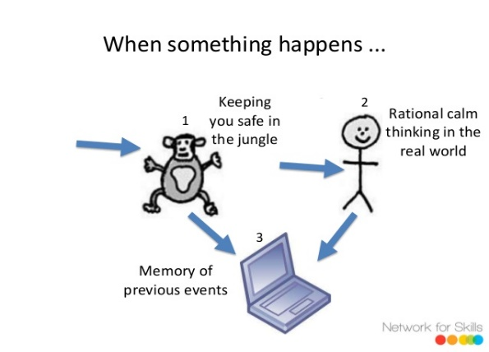
Leap the Limbic, Living so Logic
Why do we have thoughts of failure – lack of confidence – stress – anxiety and anger? What controls and drives this? Find out how your brain can sabotage by thinking and acting negatively and putting barriers up to stop you from being the best version of you.
When you know why, the strategies you will learn in this session will help you to think logically and positively in a life much more positive and fulfilled.
Wednesday 29th January 2020
12:15-2:45 Llanrwst

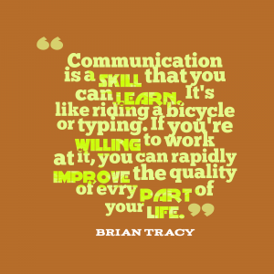
Hang on to that thought
Remembering important information is so much easier and quicker when you know the most suitable way, this workshop which is fun and interactive will help you to communicate. When communicating with people who see everything in a different way it can be difficult, knowing what words and phrases get
Attention in a calm and friendly approachable manner gain best results every time, learn this whilst on the course.
Friday 31st January 2010
9:30-12 Aberegele

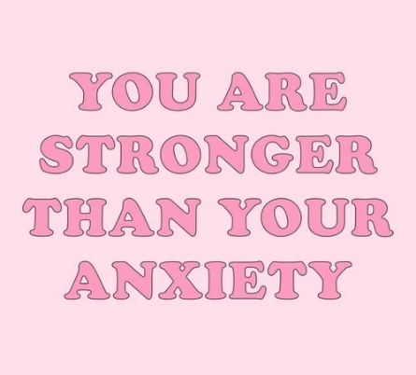
Bridging the Anxiety Gap
Two-week course
Living with anxiety is really difficult. How we feel can cause many problems like:
Loss of appetite, sleeping problems and difficulty concentrating. These sessions will help you to understand WHAT happens when you are anxious, WHY we have certain symptoms and HOW to manage them to be the best version of you.
Friday 7th & 14th February 2020
12-2:30 Llanrwst

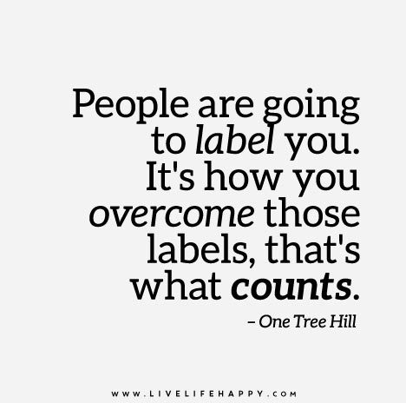
Relabel your life
We move towards what we feel we deserve, if we want a great life our thoughts and how we see ourselves drive this, if we have negative views or labels about us then these need to be removed and replaced with positive labels, learn how to re label your life with SAFE.
Friday 28th February 2020
12-2:30 Llanrwst
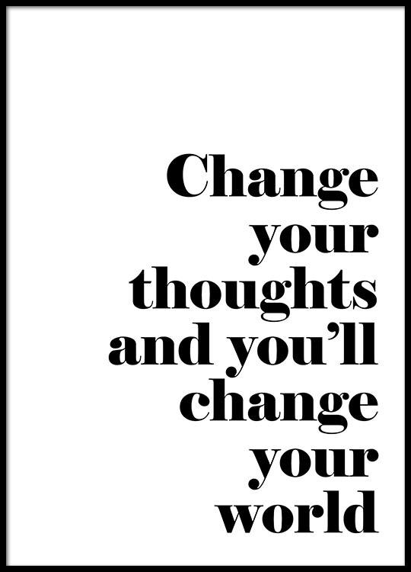
Thoughts are not facts
Have you noticed how closely linked our thoughts, feelings and emotions are and that our mind often jumps to conclusions and makes up all sorts of stories about what it sees.
A helpful way of dealing with these stories is to remember THOUGHTS ARE NOT FACTS!
Friday 6th March 2020
9:30-12 Abergele

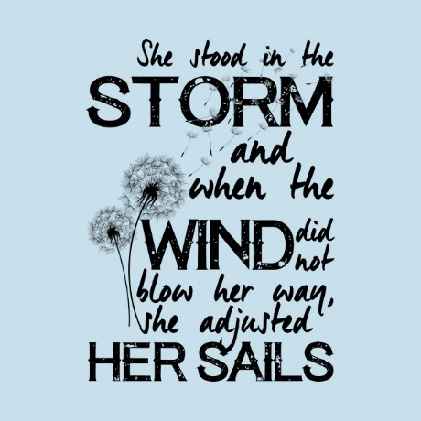
Understanding Emotional Resilience
Emotional resilience isn’t about not having troubles or not going through stressful life events, it’s about being able to cope with them better.
In this session we will look at what emotional resilience is and what we can do to develop better bounce-back ability.

Wednesday 11th March 2020
9:30-12 Abergele

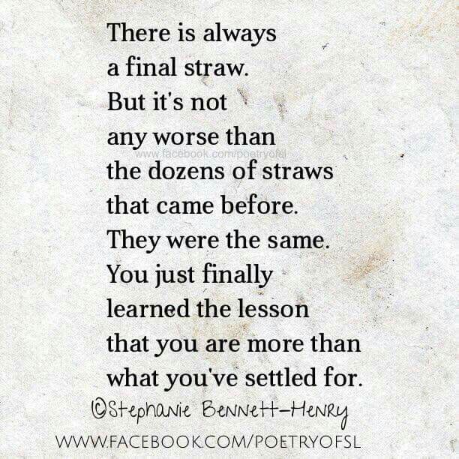
The Straw that Broke the Camel’s Back
A look at the importance of not letting stresses and anxieties build up to a pressure point that can create their own issues.
Learn strategies to work on creating a calm logical thinking you.
Friday 13th March 2020
12-2:30 Llanrwst
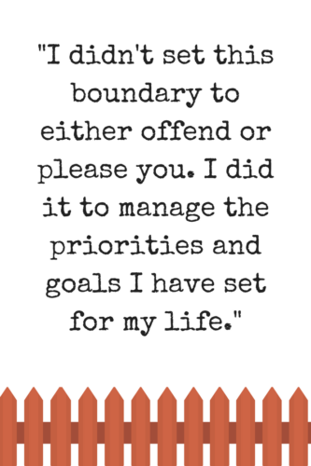
SAFE Personal Boundaries
Having personal boundaries can be difficult.
We naturally want to please people and we don’t
like to say no when asked for help.
However, having SAFE personal boundaries is important to maintain good relationships and good communications.
Why not come along and find out what your boundaries are?

Friday 20th March 2020
9:30-12 Abergele
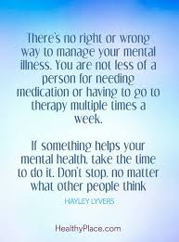
The Thief and me
Mental ill health can be overwhelming, it’s like the thief that gradually steals away from you things like, your confidence, self – esteem, your energy and enthusiasm. This useful workshop will look at the thief in all forms and help you to improve your strategies to keep it at bay.

Friday 27th March 2020
9:30-12 Abergele

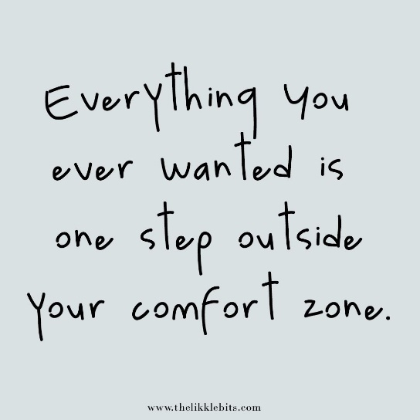
Its SAFE to step forward
Do you struggle in new situations with new people where the focus is on you, learn how to grow your levels of confidence, try new things and join into conversations that you would have previously avoided.

Thursday 23rd April 2020
9:30-12 Abergele

Review
This review session will be a lovely way to reflect on our progress. Your thoughts, opinions and suggestions are invaluable to us. We will sit down together and look at what has worked, what we can improve and what sessions you think may benefit you in the future.
Friday 24th April 2020
12-2:30 Llanrwst
Wednesday 29th April 2020
9:30-12 Abergele

To Book onto any of these sessions please contact:
Sarah Bowen on:
Mob: 07803 628299
Office: 01352 759332
Email: sarah@asnew.org.uk
Or
Clive Roland on:
Mob: 07803 628303
Office: 01352 759332
Email: clive@asnew.org.uk

We look forward to working with you

Sarah & Clive
SAFE facilitators

Date | Location | Course | Parking | Time
Fri 17th January | Llanrwst | Building Blocks for Confidence  Part 2 | Watling Street Car Park  Llanrwst LL26 0LS Aprox 60yrd  1-2 min walk | 12-2:30
Fri 24th January | Llanrwst | Recognising your Strengths | Watling Street Car Park  Llanrwst LL26 0LS Aprox 60yrd  1-2 min walk | 12-2:30
Wed 29th  January | Llanrwst | Leap the Limbic Living so Logic | Watling Street Car Park  Llanrwst LL26 0LS Aprox 60yrd  1-2 min walk | 12:15-2:45
Fri 31st January | Abergele | Hang on to that Thought | Next to venue | 9:30-12
Fri 7th February | Llanrwst | Bridging the Anxiety Gap  Part 1 | Watling Street Car Park  Llanrwst LL26 0LS Aprox 60yrd  1-2 min walk | 12-2:30
Fri 14th February | Llanrwst | Bridging the Anxiety Gap  Part 2 | Watling Street Car Park  Llanrwst LL26 0LS Aprox 60yrd  1-2 min walk | 12-2:30
Fri 28th February | Llanrwst | Re Label your Life | Watling Street Car Park  Llanrwst LL26 0LS Aprox 60yrd  1-2 min walk | 12-2:30
Fri 6th March | Abergele | Thoughts are not Facts | Next to venue | 9:30-12
Wed 11th  March | Abergele | Understanding Emotional Resilience | Next to venue | 9:30-12
Fri 13th March | Llanrwst | The Straw that Broke the Camel’s Back | Watling Street Car Park  Llanrwst LL26 0LS Aprox 60yrd  1-2 min walk | 12-2:30
Fri 20th March | Abergele | SAFE personal Boundaries | Next to venue | 9:30-12
Friday 27th March | Abergele | The Thief and me | Next to venue | 9:30-12
Thurs 23rd April | Abergele | It’s SAFE to Step Forward | Next to venue | 9:30-12
Fri 24th April | Llanrwst | Review | Watling Street Car Park  Llanrwst LL26 0LS Aprox 60yrd 1-2 min walk | 12-2:30
Wed 29th  April | Abergele | Review | Next to venue | 9:30-12
Canolfan Dinorben  Faenol Ave,  Abergele LL22 7HT  01492 577757 |  | Llanrwst Family Centre  Church House, Watling St, Llanrwst LL26 0LS  01492 574140

